Identity Repository REST Services

# Background

Identity Repo REST service can be used internally by products to create, read and update Identity information and to validate an input UIN.

## Target users -

Registration Processor can use Identity Repo services to create and update Identity information associated with a UIN. ID Authentication can use Identity Repo services to validate an input UIN and read identity details associated with a UIN.

## Key requirements -

* Create UIN and associate input identity information with the created UIN and store
* Update Identity information partially or status of UIN
* Read Identity Information associated with a valid UIN
* Check status of UIN for validating a UIN

## Key non-functional requirements –

* Log :
  + Log all the exceptions along with error code and short error message
  + As a security measure, Individual’s UIN should not be logged
* Audit :
  + Audit all transaction details in database
  + Individual’s UIN details should not be audited
* Exception :
  + Any error in storing or retrieval of Identity details should be handled with appropriate error code and message in IdResponse
* Security

<<TBD>>

# Solution

Identity Repo REST services addresses the above requirements as explained in below services in details.

## Class Diagram

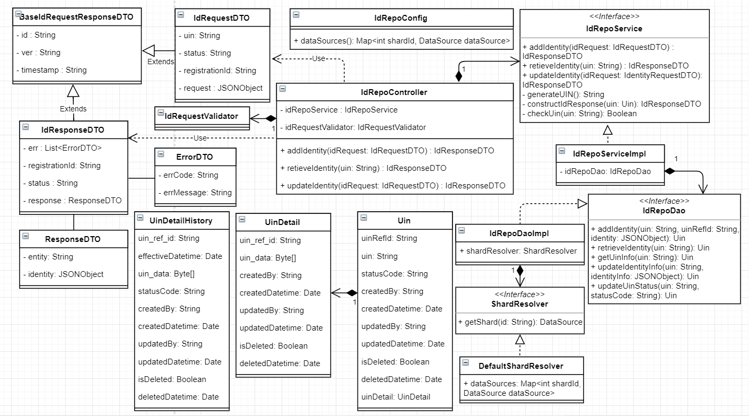

## REST Services

## Create Identity

1. MOSIP Products to construct a **POST** request with below details and send to Request URL /**identity**

Sample Request Body –

{

"id": "mosip.id.create",

"ver" : "1.0",

"timestamp" : "",

"registration-id" : "",

"request" : {

"identity": {

"firstName": [

{

"language": "ar",

"label": "الاسم الاول",

"value": "ابراهيم"

},

{

"language": "fr",

"label": "Prénom",

"value": "Ibrahim"

}

],

"middleName": [

{

"language": "ar",

"label": "الاسم الأوسط",

"value": "بن"

},

{

"language": "fr",

"label": "deuxième nom",

"value": "Ibn"

}

],

"lastName": [

{

"language": "ar",

"label": "الكنية",

"value": "علي"

},

{

"language": "fr",

"label": "nom de famille",

"value": "Ali"

}

],

"dateOfBirth": [

{

"language": "ar",

"label": "تاريخ الولادة",

"value": "16/04/1955"

},

{

"language": "fr",

"label": "date de naissance",

"value": "16/04/1955"

}

],

"gender": [

{

"language": "ar",

"label": "جنس",

"value": "الذكر"

},

{

"language": "fr",

"label": "le sexe",

"value": "mâle"

}

],

"addressLine1": [

{

"language": "ar",

"label": "العنوان السطر 1",

"value": "عنوان العينة سطر 1"

},

{

"language": "fr",

"label": "Adresse 1",

"value": "exemple d'adresse ligne 1"

}

],

"addressLine2": [

{

"language": "ar",

"label": "العنوان السطر 2",

"value": "عنوان العينة سطر 2"

},

{

"language": "fr",

"label": "Adresse 2",

"value": "exemple d'adresse ligne 2"

}

],

"addressLine3": [

{

"language": "ar",

"label": "العنوان السطر 3",

"value": "عنوان العينة سطر 3"

},

{

"language": "fr",

"label": "Adresse 3",

"value": "exemple d'adresse ligne 3"

}

],

"region": [

{

"language": "ar",

"label": "رمنطقة",

"value": "طنجة - تطوان - الحسيمة"

},

{

"language": "fr",

"label": "Région",

"value": "Tanger-Tétouan-Al Hoceima"

}

],

"province": [

{

"language": "ar",

"label": "المحافظة",

"value": "فاس-مكناس"

},

{

"language": "fr",

"label": "province",

"value": "Fès-Meknès"

}

],

"city": [

{

"language": "ar",

"label": "مدينة",

"value": "فاس-الدار البيضاء"

},

{

"language": "fr",

"label": "ville",

"value": "Casablanca"

}

],

"localAdministrativeAuthority": [

{

"language": "ar",

"label": "الهيئة الإدارية المحلية",

"value": "طنجة - تطوان - الحسيمة"

},

{

"language": "fr",

"label": "Autorité administrative locale",

"value": "Tanger-Tétouan-Al Hoceima"

}

],

"mobileNumber": [

{

"language": "ar",

"label": "رقم الهاتف المحمول",

"value": "+212-5398-12345"

},

{

"language": "fr",

"label": "numéro de portable",

"value": "+212-5398-12345"

}

],

"emailId": [

{

"language": "ar",

"label": "عنوان الايميل",

"value": "sample@samplamail.com"

},

{

"language": "fr",

"label": "identifiant email",

"value": "sample@samplamail.com"

}

],

"CNEOrPINNumber": [

{

"language": "ar",

"label": "رقم CNE / PIN",

"value": "AB453625"

},

{

"language": "fr",

"label": "Numéro CNE / PIN",

"value": "AB453625"

}

],

"parentOrGuardianName": [

{

"language": "ar",

"label": "اسم ولي الأمر / الوصي",

"value": "سلمى"

},

{

"language": "fr",

"label": "Nom du parent / tuteur",

"value": "salma"

}

],

"parentOrGuardianRIDOrUIN": [

{

"language": "ar",

"label": "الوالد / الوصي RID / UIN",

"value": "123456789123"

},

{

"language": "fr",

"label": "parent / tuteur RID / UIN",

"value": "123456789123"

}

],

"leftEye": [

{

"language": "ar",

"label": "العين اليسرى",

"value": "hashed_fileName.png"

},

{

"language": "fr",

"label": "oeil gauche",

"value": "hashed_fileName.png"

}

],

"rightEye": [

{

"language": "ar",

"label": "العين اليمنى",

"value": "hashed_fileName.png"

},

{

"language": "fr",

"label": "l'œil droit",

"value": "hashed_fileName.png"

}

],

"leftSlap": [

{

"language": "ar",

"label": "البيومترية المسح الضوئي 1",

"value": "hashed_fileName.png"

},

{

"language": "fr",

"label": "analyse biométrique 1",

"value": "hashed_fileName.png"

}

],

"rightSlap": [

{

"language": "ar",

"label": "البيومترية المسح الضوئي 2",

"value": "hashed_fileName.png"

},

{

"language": "fr",

"label": "analyse biométrique 2",

"value": "hashed_fileName.png"

}

],

"thumbs": [

{

"language": "ar",

"label": "البيومترية المسح الضوئي 3",

"value": "hashed_fileName.png"

},

{

"language": "fr",

"label": "analyse biométrique 3",

"value": "hashed_fileName.png"

}

]

}

}

}

1. Integrate with Kernel UIN Generator to create UIN
2. Below are the various status associated with a UIN –
   1. REGISTERED
   2. BLOCKED
   3. DEACTIVATED
3. Once UIN is generated, assign “**REGISTERED**” as UIN status. UIN, status and Identity details are then stored in UIN and UIN_detail table
4. Respond with below success Identity response -

{

"id" : "mosip.id.create",

"ver" : "1.0",

"timestamp": "",

"registrationId" : "",

"status" : "REGISTERED",

"err" : {},

"response" : {

"entity" : "http://mosip.io/identity/7867780967875678"

}

}

Below sequence diagram for create Identity service shows sequence of operations to create UIN and store corresponding Identity details.

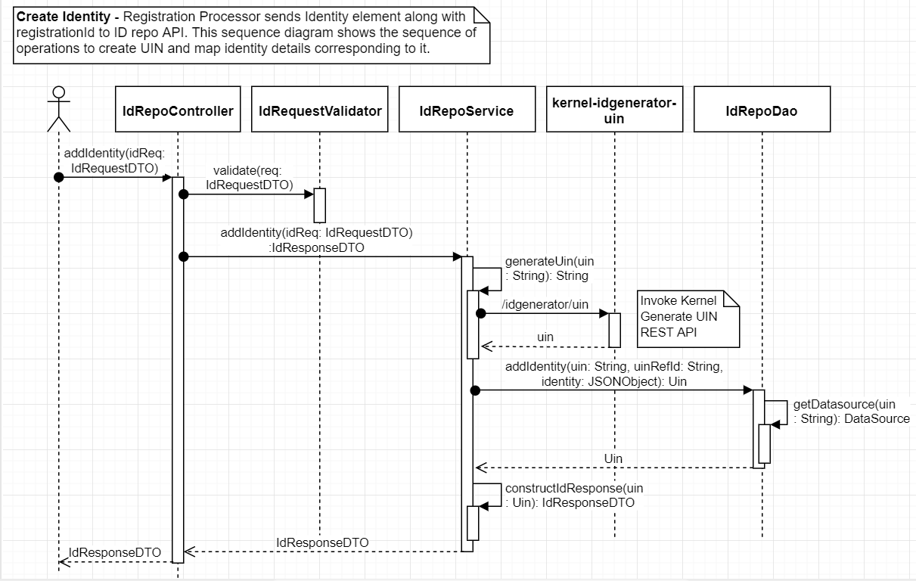

## Update Identity

1. MOSIP Products to construct a **PATCH** request with below details and send to Request URL /**identity/<UIN>**

Sample Request Body –

{

"id" : "mosip.id.update",

"ver" : "1.0",

"timestamp" : "",

"uin" : "7867780967875678",

"status" : "BLOCKED",

"request" : {

"identity": {

"addressLine1": [

{

"language": "ar",

"label": "العنوان السطر 1",

"value": "عنوان العينة سطر 1"

},

{

"language": "fr",

"label": "Adresse 1",

"value": "exemple d'adresse ligne 1"

}

],

"addressLine2": [

{

"language": "ar",

"label": "العنوان السطر 2",

"value": "عنوان العينة سطر 2"

},

{

"language": "fr",

"label": "Adresse 2",

"value": "exemple d'adresse ligne 2"

}

],

"addressLine3": [

{

"language": "ar",

"label": "العنوان السطر 3",

"value": "عنوان العينة سطر 3"

},

{

"language": "fr",

"label": "Adresse 3",

"value": "exemple d'adresse ligne 3"

}

],

"region": [

{

"language": "ar",

"label": "رمنطقة",

"value": "طنجة - تطوان - الحسيمة"

},

{

"language": "fr",

"label": "Région",

"value": "Tanger-Tétouan-Al Hoceima"

}

],

"province": [

{

"language": "ar",

"label": "المحافظة",

"value": "فاس-مكناس"

},

{

"language": "fr",

"label": "province",

"value": "Fès-Meknès"

}

],

"city": [

{

"language": "ar",

"label": "مدينة",

"value": "فاس-الدار البيضاء"

},

{

"language": "fr",

"label": "ville",

"value": "Casablanca"

}

],

"localAdministrativeAuthority": [

{

"language": "ar",

"label": "الهيئة الإدارية المحلية",

"value": "طنجة - تطوان - الحسيمة"

},

{

"language": "fr",

"label": "Autorité administrative locale",

"value": "Tanger-Tétouan-Al Hoceima"

}

]

}

}

}

1. Integrate with Kernel UIN validator to validate UIN
2. Once the request is successfully validated, update Identity details in UIN and UIN_detail tables
3. Respond with below success Identity response –

{

"id": "mosip.id.update",

"ver": "1.0",

"timestamp": "",

"uin": "1234567890",

"registrationId": "",

"status": "BLOCKED",

"err": {},

"response" : {

"entity" : "http://mosip.io/identity/7867780967875678"

}

}

Below sequence diagram for Update Identity service shows sequence of operations to update Identity details associated with a UIN.

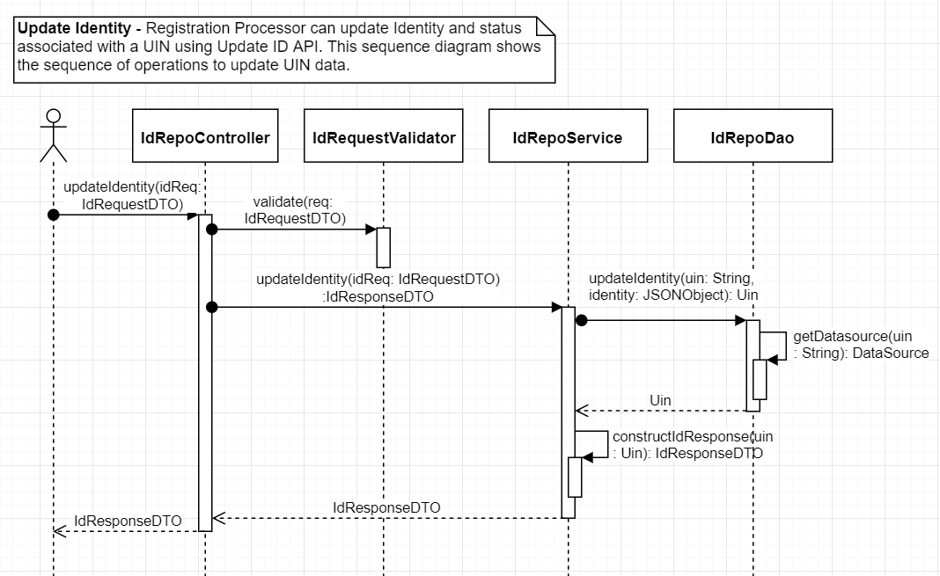

## Get Identity

1. MOSIP Products to construct a **GET** request with below details and send to Request URL /**identity/<UIN>**
2. Integrate with Kernel UIN validator to validate UIN
3. Once the request is successfully validated, retrieve Identity details in UIN and UIN_detail tables
4. Respond with below success Identity response –

{

"id" : "mosip.id.read",

"ver" : "1.0",

"timestamp" : "",

"err": {},

"status": "REGISTERED",

"uin" : "7867780967875678",

"response" : {

//JSON object as per the ID Object Schema defined by the system owner

}

}

Below sequence diagram for create Identity service shows sequence of operations to retrieve Identity details associated with a UIN.

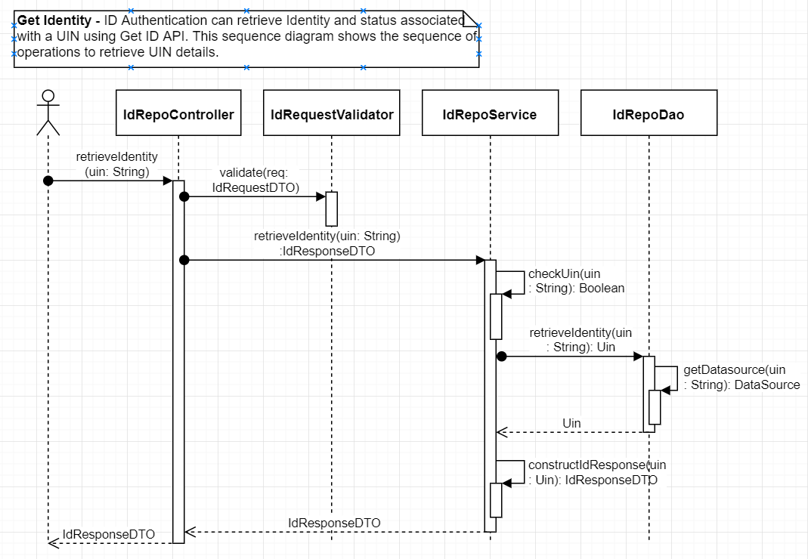

## Database Sharding

UIN DB stores UIN and the corresponding identity details. In order to decrease load and increase search performance, UIN DB is horizontally partitioned into shards. Each shard is a separate database instance with same tables and rows in tables are distributed across shards.

ID Repo provides default shard implementation where shards are decided based on starting character of UIN. Below diagram shows the approach for sharding UIN DB.

